# **Opening Retail Minor Account**

1. Select the menu – “OSA” **Open Current Account**
2. Key in Verified Minor CIF
3. Select Scheme Code **MINOR** from the searcher
4. Click Go Button
5. CIF Details Will be displayed
6. Set Statement Frequency
7. Click Continue Button
8. Skip from additional Details Page to IMIS Details

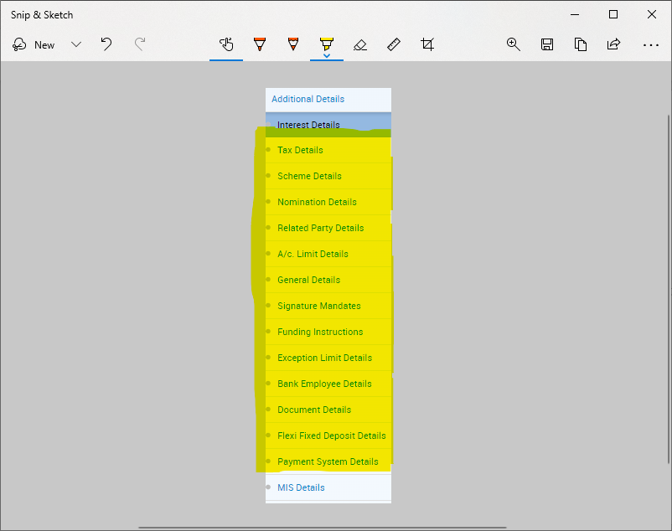

**Skip The highlighted page**

1. Select Sector Code & Subsector (Ensure they match e.g Sector code 05 **ENERGY AND WATER** , subsector 0501 “**ENERGY AND WATER_ELECTRICITY, LIGHT AND POWER”**)
2. Click on free code 
3. Select Business Economic Activity Code- **Should relate to sector & subsector selected**
4. Click Free Text
5. Key In Purpose of account
6. Key In Source of funds
7. Select Bank Specific Sector Code
8. Select Bank Specific Sub Sector Code
9. Select ARO Code
10. Click Submit Button and note the account Number

**Photo & Signature Capture**

1. Invoke CACOF menu
2. Key in Account no
3. Using signature pad and webcam capture signature, photo, and Identification document for the parent / guardian
4. Click Submit

**Generate Account opening Mandate**

1. Invoke PQR menu to download account opening form
2. Invoke MOSAV menu to attach the generated account opening mandate
3. Key in the account Number
4. Visit Document details page & attach the mandate.
5. Click submit for verification

# **Account Opening Verification**

1. Checker Select Menu VSAO (Verify Savings Account Opening)
2. From Searcher select account pending verification **(Minor account)**
3. Click Go Button
4. Customer Details Displayed
5. Click continue button and view all the details capture during account opening.
6. Click Submit Button